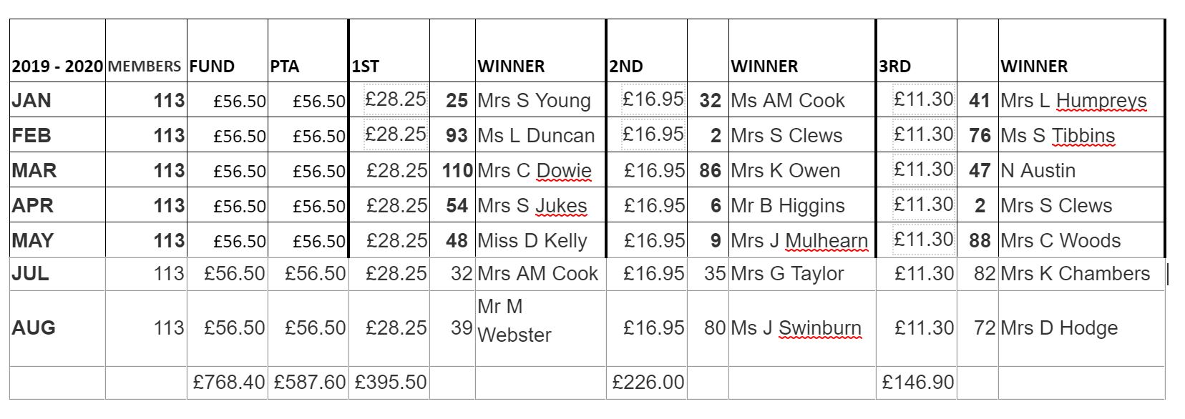200 CLUB PRIZES 2018 - 2019

