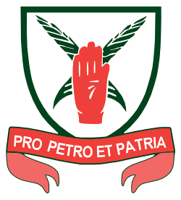
St Edmund Arrowsmith Catholic High School
Important Dates

Mock Examination Thursday 28th November to Friday 6th December
Parents Evening Thursday 16th January
Trial Examinations Thursday 27th February to Friday 6th March
Trial Results Day Wednesday 25th March
Leaving Mass 12:15pm Wednesday 6th May
Start of the GCSE Examinations Monday 11th May
Year 11 Leavers’ Assembly Tuesday 2nd June
End of the GCSE Examinations Wednesday 24th June
Pupils must be available up to and including the above date

Leavers’ Ball Friday 3rd July
Results Day 9:30am Thursday 20th August
Certificate Presentation Evening November date to be confirmed

